Template Id: 1d3db787-9da9-40fc-af44-3bce35985579
Template:
Dear {{1}},
Thank you for applying for the role of {{2}} with {{3}}.
To arrange your interview and/or receive upcoming messages/notifications regarding the process, kindly click the button below.

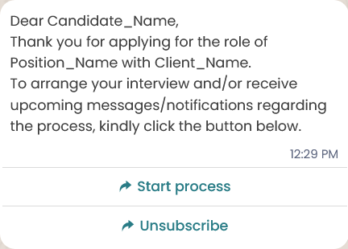

Template Id: d28437c4-6295-4afd-9ac0-8e7cacc3baff
Greetings {{1}},
Confirming the interview with {{2}} for the {{3}} role on {{4}} at {{5}}. Please confirm your availability or suggest an alternative. Any specific preferences or requirements can be communicated beforehand.
Thank you for your cooperation.

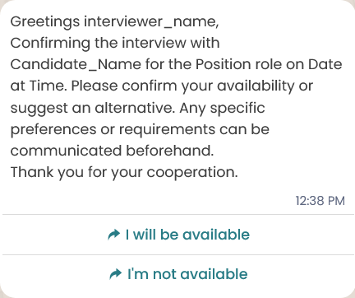
cba05e4e-73c1-4bce-829c-696d8b098103

Hello *{{1}}*,

This is to notify that *Candidate {{2}}* have been invited to attend Video Interview on *{{3}}* for the position of *{{4}}*.

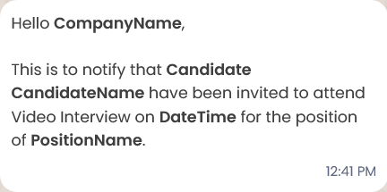

b469c4c9-dbb9-48d8-8ca9-06d3b6488d3e
Hi,
*Candidate {{1}}* ({{2}}) has *completed* the video interview on *{{3}}* for the *{{4}}* role.

The interview report and video will be available with the candidate profile shortly.

0575516d-f6bc-4532-b8d7-c193d2e5df1f

Hi *{{1}}*,

We've been trying to reach you regarding your interview for the *{{2}}* role at *{{3}}*.

Please let us know a suitable time to connect.
Looking forward to hearing from you

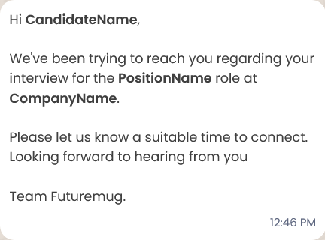

edb3b0b0-9fb5-4c13-9742-05c8e55eefb0

Hi,
*Candidate {{1}}* ({{2}}) was a *not responding* for the scheduled interview on *{{3}}* for the *{{4}}* role.

*Reason: {{5}}*
Team Futuremug will follow up shortly.

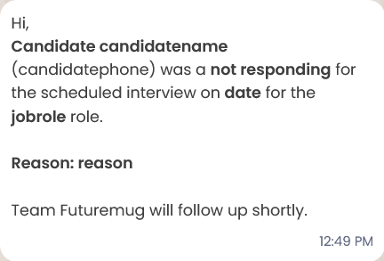

ee41f85a-b319-4ea7-a7ce-173248ab47f2

Hi,
*Candidate {{1}}* ({{2}}) was a *not responding* for the scheduled interview on *{{3}}* for the *{{4}}* role.

Team Futuremug will follow up shortly.

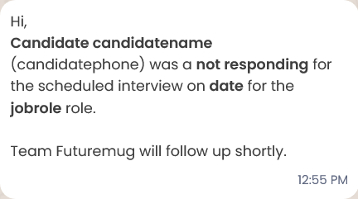

4df56c57-9d4a-4c37-938e-2971f3f0808c
Hi,
*Candidate {{1}}* ({{2}}) was a no-show for the scheduled interview on *{{3}}* for the *{{4}}* role.

*Reason: {{5}}*

Team Futuremug will follow up shortly.

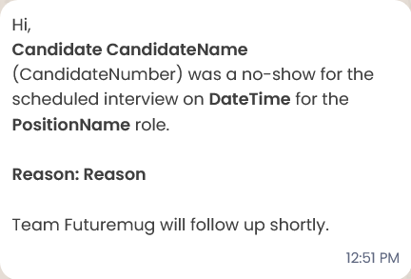

f62eec37-2d3a-4027-bfca-2728d327a2e5
Hi,
*Candidate {{1}}* ({{2}}) was a *no-show* for the scheduled interview on *{{3}}* for the *{{4}}* role.

Team Futuremug will follow up shortly.

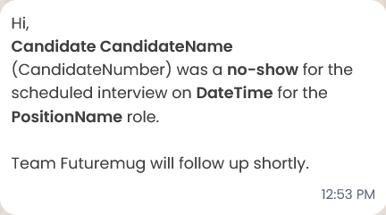

75c0093f-439b-46c1-9c16-c0a9928c7d83
Hi,
*{{1}}* ({{2}}) has requested to reschedule the interview scheduled on *{{3}}* for the *{{4}}* role.

*Reason: {{5}}*
We’ll coordinate a new time slot soon.

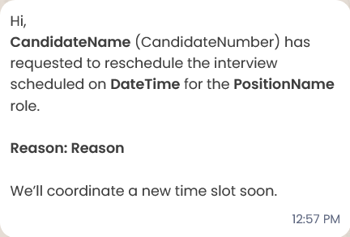
18d3503a-d93c-419c-b987-c163eaf22cc8
Hi,
*{{1}}* ({{2}}) has requested to *reschedule* the interview scheduled on *{{3}}* for the *{{4}}* role.

We’ll coordinate a new time slot soon.

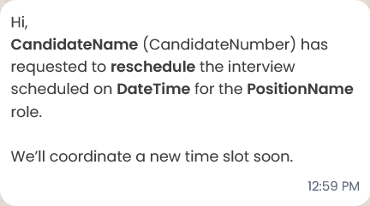

376894cc-1322-4408-8f93-870d75c64096
Hi,
The interview for *Candidate {{1}}* ({{2}}) scheduled on {{3}} for the *{{4}}* role has been cancelled.

*Reason: {{5}}*

No report/video will be available for this session.

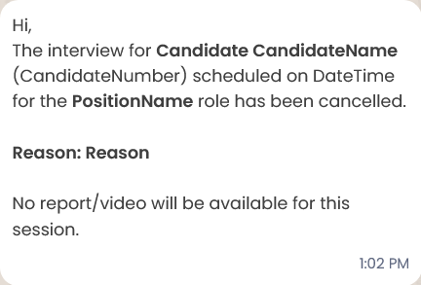

f8a56284-ba02-4bd1-94c8-265fc3447e86
Hi,
The interview for *Candidate {{1}}* ({{2}}) scheduled on *{{3}}* for the *{{4}}* role has been *cancelled*.

No report/video will be available for this session.

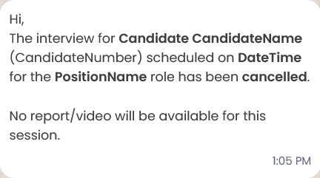

df8997f9-c3b7-46ba-9669-9e0aaf4688a6
Hi,
*Candidate {{1}}*
({{2}}) is *not interested* in proceeding with the interview process for the *{{3}}* role.

*Reason: {{4}}*

The process is now closed for this candidate.

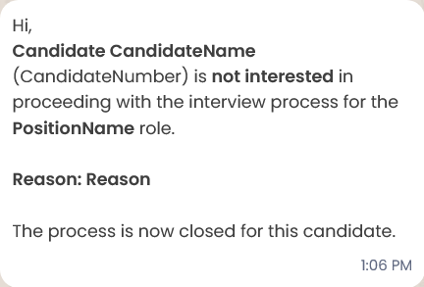

1f7a9cdf-1e4a-461f-9536-80c3f03e4cf8
Hi,
*Candidate {{1}}* ({{2}}) is not interested in proceeding with the interview process for the *{{3}}* role.

The process is now closed for this candidate.

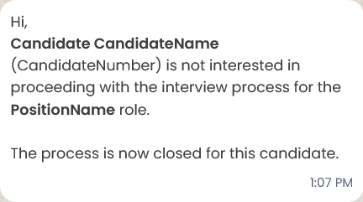

52c08e94-8d20-4a04-84f2-fc792e401dd6
Hi,
*Candidate {{1}}* ({{2}}) has *dropped out* of the interview process for the *{{3}}* role.

*Reason: {{4}}*

No further interviews will be scheduled.

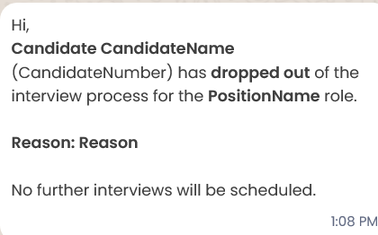

1a25a391-15b1-4c0e-8400-23f2ae20b7bd
Hi,
*Candidate {{1}}* ({{2}}) has dropped out of the interview process for the *{{3}}* role.
No further interviews will be scheduled.

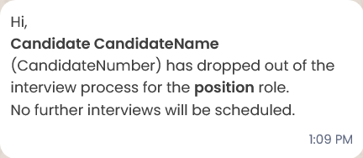

a59e11b2-cda8-43a2-a1e7-9c23abb3c351

Job Update ⏰

A new job description has been added.

Job Role: {{1}}
Client Name: {{2}}
Date Created: {{3}}

This message is for notification purposes only.

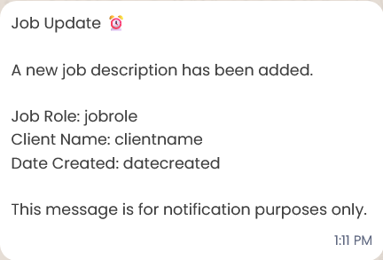
c9668c51-678b-44f0-976e-e2cd3416d4c6
⏰ Reminder ⏰
Please complete filling the interview report at the earliest, as the allotted time has already passed.

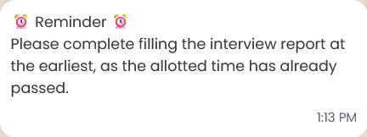

ed09a020-edbb-40de-852c-67fe2e5a1351
Your interview has been scheduled with {{1}} for the position of {{2}} on {{3}} at {{4}}. Please check your email for the interview link and additional notifications.

Best regards,
Technical Interviews Team
futuremug

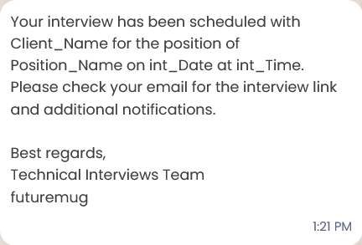

0d4e005b-6d34-4d90-8f2c-54365ebbe671
Your interview with {{1}} for the position of {{2}} is confirmed for {{3}} at {{4}}
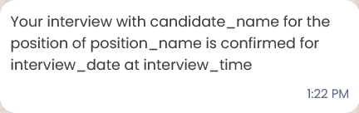

980059ce-b47f-49f4-b03e-ce54d69a0ac6
Hi {{1}}! This is a reminder for your interview scheduled on {{2}} at {{3}}. Please be prepared!
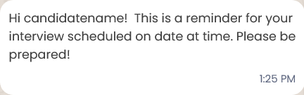

6f5ee1d0-0a46-447b-92dd-2d5926cad943
Account Update ⏰

Hi {{1}}, your {{2}} for {{3}} are as follows:

🔗 {{4}}
👤 {{5}}
🔐 {{6}}

Need any help? Contact {{7}} at {{8}}.

Team futuremug

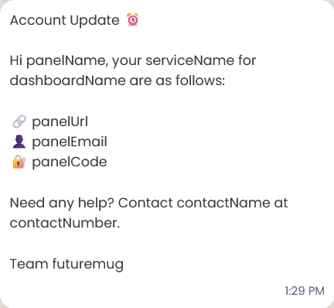

97c6a4ab-2e9c-4838-8a15-2053ebb5061f
Hello *{{1}}*,

Quick update on the *{{2}}* candidate:
As per the initial review, the candidate is marked as *{{3}}*. After further evaluation the detailed report will be shared shortly.

The verdict may change after further evaluation.

Candidate Name: *{{4}}*
Interview Date: *{{5}}*

Team futuremug



